Job # 2903

1. More then 1 minute to load -sync data
2. Tag # not in French
3. Debrief screen:- Chinese language :- Clarity label in English
4. French -Time screen:- Date label in English
5. Material screen:- Date , justification
6. Serial # quantity mismatch:-

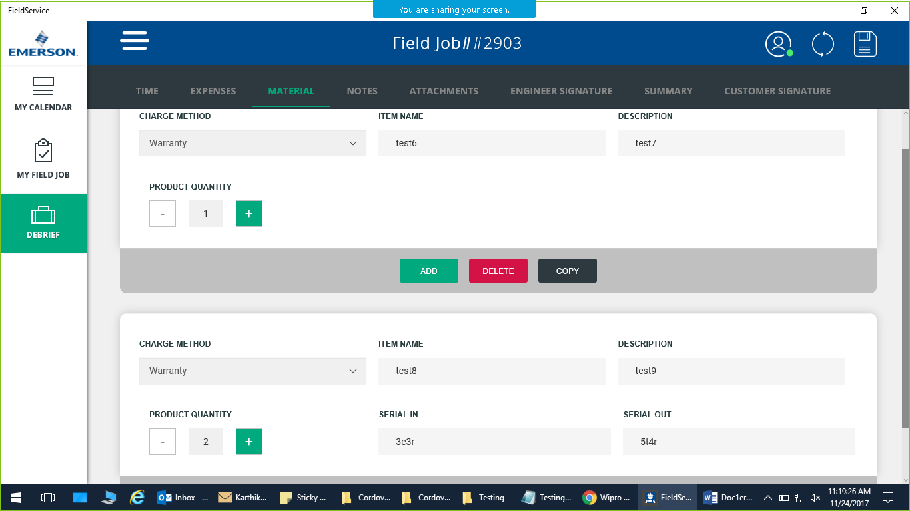

1. Summary screen not matching time data entered in the debrief.

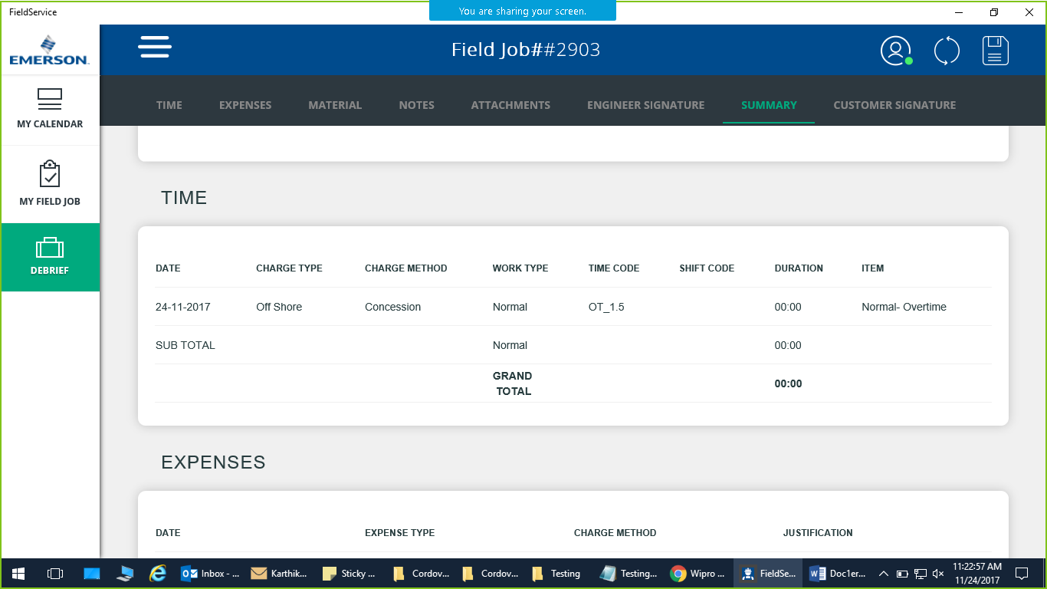

1. After submission , status didn’t change to completed in job list.Had to sync
2. Star and end time changed after completion :- 6.35 am -> 11.08 am.

-Offline mode testing--

#2904 no issues observed.

Job # 2909

1. Contact and product not synced in first 2 syncs (login & then manual sync). + 15 mins
2. Sync taking long times into 3-4 mins.
3. 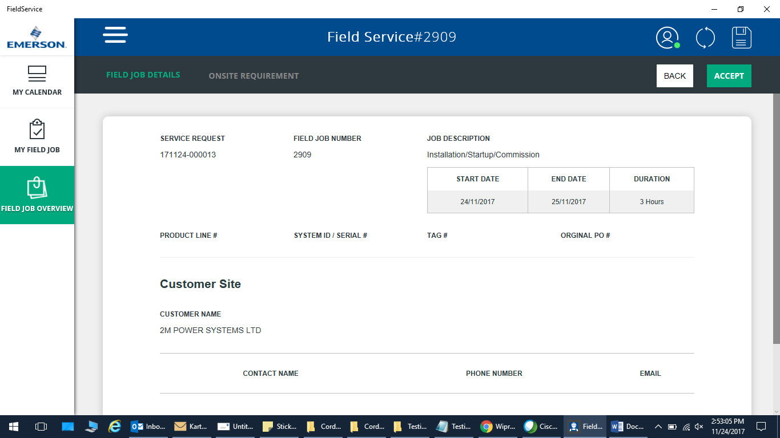
4. Job not shown in calendar ..may be its scheduled in the night hours which are not shown on calendar.start time 11.39 pm , 3 hrs.

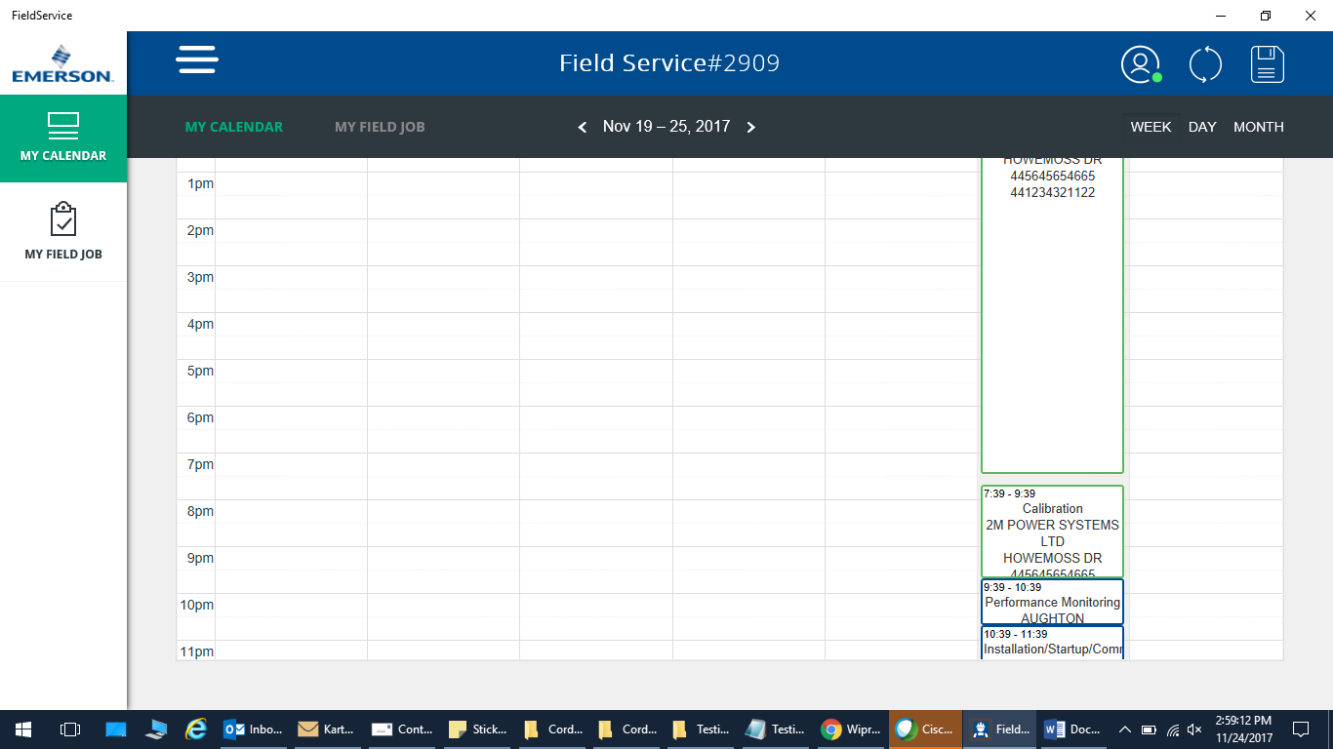

1. Did not complete on clicking of done button on summary tab.
2. Sync refresh taking avg 4 mins(Alex) ..during which user cannot do anything.

---------------------------------------------------------------------------------------------------------

---Non clarity user

Rohan.palan /Wipro@123

Job # 2906

1. Time-summary section showing ‘NAN’ value

